WOODSBERG
Requirements List
Admin
- Dashboard showing product catalog and settings redirected to that pages.
- Designing header section and footer section
- Catalog page display all products with search functionality and stock quantity
- Each product have edit and remove option
- Option for disabling product from admin side using out of stock
- Option for pagination in product listing
- Order listing page with multiple tab retail, wholesale, b2b, export
- Order view page using pop up with display all order items
- Report with search filters using date, order type, name, phone number
- Settings page have option for creating category, subcategory, testimonial, user, coupon code, slider, shipping charges
- Load ERP products in admin add product page.
Retail Website
- Home page design
- Header
- Slider
- Product categories
- Featured products
- Best seller
- Seasonal offer
- Testimonial
- Footer
- Product category listing page design
- Single product page design
- Cart page design
- Checkout page with shipping and coupon code
- Payment gateway
Wholesale
- Product listing page
- Single product page
- Cart page
- Checkout page only with company details
- Order details listing in admin
B2B
- Product listing page
- Single product page
- Cart page
- Checkout page only with company details
- Order details listing in admin
Export
- Product listing page with dollar price
- Single product page
- Cart page
- Checkout page only with company details
- Order details listing in admin

Task List

- Add category
- Add product subcategory
- Add Product page
- Edit product
- Option for multiple product pricing
- Option for enable out of stock evenif product available
- Add purchase option from wish list
- Default ‘out of stock’ visible for each product in Admin dashboard
- Seasonal offer assignment product wise (Text boxes for Retail price, % value, offer price) Seasonal offer is only for Retail customers.
- Weight field should be in Kg and Gm format.
- Autogenerate order number in a particular format.
- Detailed report and search option using date, name, and phone number
- Price Listing (Only for Admin
- Add product code and display name and code for each product.
- Order of Price (Price LC, Retail price, wholesale price, Franchise price)
- Admin should access checkout data.
- Automatic email (order summary) send option needed for Retail, wholesale, Franchise customers . - 8h
- Payment gateway. - 20h
- Stock management. – 3h
- Add promotional offer and Discounted sale (Phase 2)
- Account for Wholesale and Franchise customers (Phase 2).
- Add Export Product page.(Price LC, Category, Product name, Whole sale price(Dollars), is home, is best seller, out of stock, 4 images). No shipping, no seasonal offer. – 2h
- Add Category section under About Us section. – 1h
- Dynamically listing categories from Db – 20min
- Listing Category wise Products in category listing page - 30min
- Create Dynamic section sub category listing in category page – 1h
- Create a single product page for each category - 30min
- Add to cart functionality with stock management in category single page – 2h
- Create a checkout page for Export – 30min
- Save checkout Details and Order Details into the Db - 1h
- Listing Export Order Details in admin – 30min
- Order Details View In Popup -1h
- Same time multiuser checking(using logout). - 8h
- Change the slider - 3h
- Testing the woodsberg - 4h
- Fixing the bug after testing – 8h
- Change product catalog icon in admin side – 10 min
- Add save alert in add new product page - 10min
- Add image validation in add product page – 10min
- Postal code numeric validation in checkout page
- Product details loading image – 10min
- Change the ui in admin side in product section and its functionalities – 1h
- Change the image height and width in website – 10min
- Integrate the cart page functionalities in export website – 1h
- Fixing the testing issue in retail – 1h
- Website integrate the checkout function in retail website – 3h
- Subcategory list order – 30 min
- Not show Best sellers, seasonal offers headings if not available.-30 min
- Count check in Home page and category.-20min
- No need to increment out of stock item count.-20min
- Pay button padding in Order summary.-10min
- Border setting in Order summary.-10min
- Capitalize 'T' in Subtotal. – 10min
- Table heading Bold.-10min
- Heading change- Dual verification – 10min
- Dual verification needed data:- Customer name, Transaction ID, Amount, Date and Time – 1.5hr
- Redirect to Home page from Wishlist while choosing continue shopping – 10min
- Style the payment failed page – 2hr
- Style the payment Success page – 2hr
- Fixing the price change when the decrement btn clicked in home page – 15min
- Hide the amount in payment failed page -15min
- Remove the unwanted echo -10min
- Login page needed for wholesale customer.
- Wholesale customer registration by Admin(Required fields are Shopname, phone number and email id, place. Shopname and phone number fields are mandatory)
- Username should be shopname and password should be phonenumber.
- Email(username and password) should be send to wholesaler after registration.(whatsapp also)
- Login details of wholesaler should be listed in admin side.
- Auto display of wholesale price.(Less than 40% of retail price)
- In the product page a static description of the product should be listed.

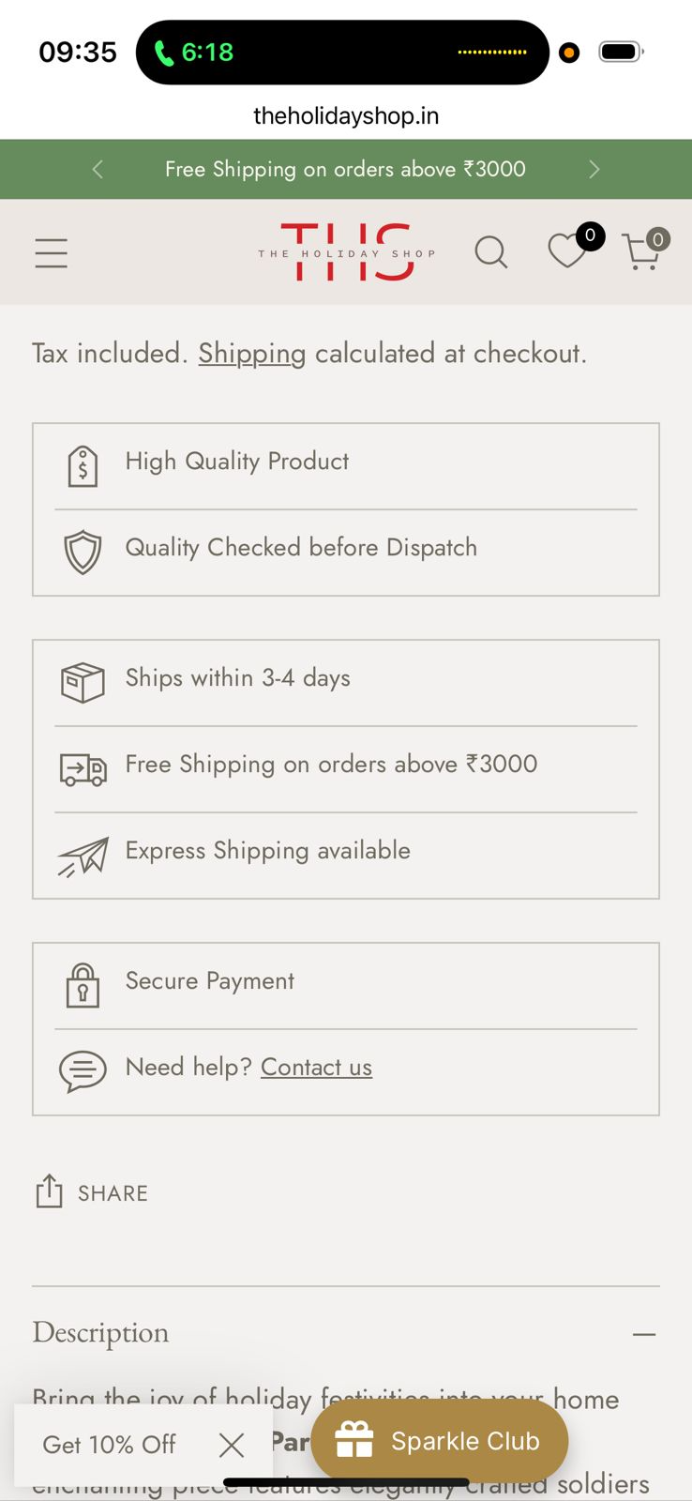
- Alert message needed while order placement.
- Dealer creation date must be shown in dealer listing
- Email Id should shown in order listing
- Add default weight 1kg for all products if there is no weight exist.
- Move X'Mas Luxe Decor category to top of the website
- Change the design of single product page

